<https://imgflip.com/i/8ie126>

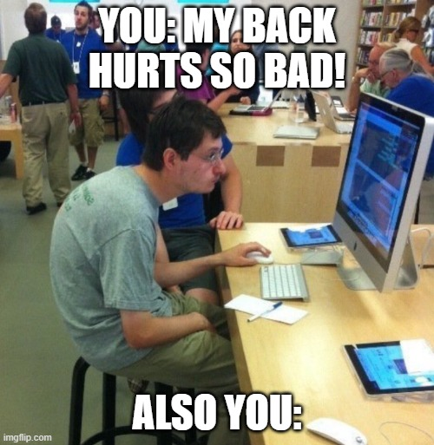

Choosing a meme that humorously addresses the issue of poor posture and its impact on one’s health reflects a relatable approach to a common problem. I chose this meme because my sister has bad posture and always complains about how her back/neck hurts.

**Employee Health Issues:**

-Increased risk of musculoskeletal disorders (MSDs) such as back pain, neck strain, and repetitive strain injuries (RSIs) due to poorly designed workspaces.

-Higher incidence of workplace-related health problems, leading to decreased productivity, and potential long-term health issues.

**Reduced Employee Morale and Engagement:**

-Uncomfortable work environments contribute to decreased job satisfaction and lower morale among employees.

-Reduced engagement and motivation, impacting overall productivity and the quality of work.

**Financial Costs for the Organization:**

-Higher healthcare costs associated with treating employees' health issues resulting from poor ergonomics.

-Increased expenses related to sick leave, and potential turnover as employees seek healthier work environments.